Setup doc

**Web-Application**

Change porm.xml file:

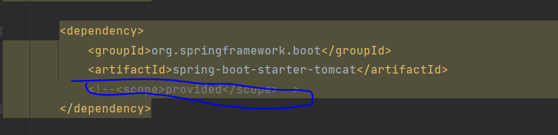

**Bulkpay.properties:**

**Database setups like, link, username, password:**

**Change idp_cert.crct file**

**Application.java:**

